**DAY 5: ASSIGNMENT**

**TOPIC: DIFFERENCE BETWEEN TRUNCATE AND DELETE COMMAND IN SQL**

**SUBMITTED TO: SUBMITTED BY:**

Prof. Jigisha patel Prabhjot Kaur

730124

There are various ways to delete rows in sql. Two of them are Truncate and delete

Truncate : Truncate is Data Definition language. Truncate is used to delete the table. But you cannot roll back. This means there’s no way to recover the data back.

Delete: Delete is Data Manipulation Language. It is used with Where clause.

DIFFERENCE BETWEEN TRUNCATE AND DELETE

TRUNCATE: This is the fastest way to delete the unnecessary data but you will have to be very careful with the TRUNCATE command because it can delete the whole row. The data which is once deleted by Truncate command can never be recovered. This command is much dangerous because it cannot be rolled back and it also sets the identity keys to default.

Syntax of Truncate command is:

Truncate table TABLE_NAME;

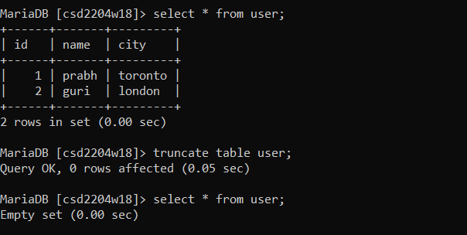

Whereas with delete, this is not the case. You can delete any specific row by using the delete command. This involves the where clause with which we can delete any particular row. Delete command works slower than truncate command. Data can be recovered back which has been deleted with the delete command. Delete command is always recommended because it is less risky and can be rolled back

Syntax of Delete command is:

Delete from TABLE NAME where (condition);

